**PROJECT OBJECTIVE:**

The objective of a product analysis project typically involves assessing a product's performance, market potential, consumer satisfaction, and other relevant factors. This analysis aims to provide insights for strategic decision-making, product improvement, marketing strategies, and enhancing overall customer experience. The specific objectives can vary based on the product type, industry, and the goals set by the project team or organization.

**PROBLEM DEFINITION:**

Understand Sales Performance**:** Gain a deep understanding of how each product in the company's portfolio is performing in terms of revenue, quantity sold, and profitability.

Customer Insights**:** Analyse customer behaviour, including purchasing patterns, demographics, and preferences, to tailor marketing strategies and product offerings.

Market Trends: Identify and react to emerging market trends, competitor strategies, and external factors affecting sales performance.

Pricing Strategy**:** Analyse the impact of pricing changes on product sales and profitability. Determine optimal pricing strategies for each product.

Inventory Management**:** Use sales data to optimize inventory levels, reducing carrying costs while ensuring products are readily available to meet demand.

**DESIGN THINKING:**

Empathize: Understand the users' perspectives, needs, and experiences related to the product. This involves conducting interviews, surveys, and observations to gather insights.

Define: Clearly articulate the problem you're trying to solve based on the information gathered during the empathize stage. Define the user's needs, challenges, and aspirations in a specific manner.

VISUALIZATION OF THE GIVEN DATASET:

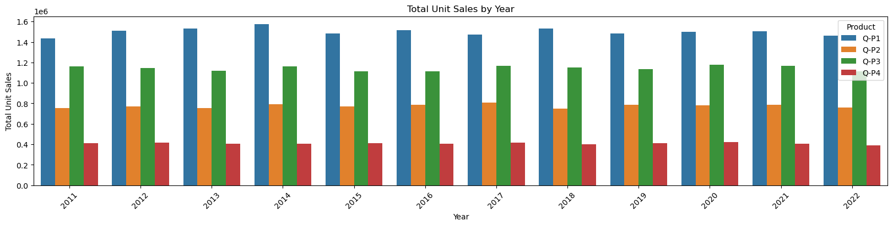

Ideate: Generate a wide range of creative ideas to solve the defined problem. Encourage brainstorming sessions and explore different possibilities without judgment.

Prototype: Develop tangible representations of the ideas generated during the ideation phase. Prototypes can be sketches, wireframes, or even simple models that help visualize the solutions.

Test: Test the prototypes with real users to gather feedback. This step involves observing how users interact with the prototypes, understanding their reactions, and refining the designs based on the feedback received.

Iterate: Based on the feedback gathered during testing, refine the prototypes and go through the testing process again. Iterative testing and refinement are crucial to developing a product that truly meets users' needs.